**Detailed information about proposal and DA submission material**

## Overview

* 1. This Development Application (DA) has been lodged by Poly Australia Pty Ltd c/- Mecone Pty Ltd for the following works at Lot 1 DP 1241790 Cudgegong Road, Rouse Hill:
* Demolition of existing structures on site including several building and sheds, with the exception of the telecommunications tower which is to remain in use until its lease expires in 2022.
* Dewatering and decommissioning of the small dam in the south-west part of the site.
* Removal of 381 trees within the R3 zoned part of the site and the retention of 164 trees in the adjacent RE1 zoned land.
* Subdivision to create 2 lots - 1 residential lot (proposed Lot 11, area 1.259 ha) and 1 lot for the existing telecommunications tower (proposed Lot 12, area 457 m2).
* Bulk earthworks and construction of a new road network comprising 3 local roads and one local half road. Additionally, approval is also sought for construction of temporary turning circles for proposed Roads 2 and 3 in order to ensure access to the existing telecommunications tower to facilitate development of the site prior to expiry of the lease in 2022.
* Construction of a multi dwelling housing development comprising 91 x 3 storey dwellings across 11 buildings (Blocks A to K), a communal club house that consists of a change room, accessible toilet, kitchen facilities and a pool.
* Construction of 3 levels of basement parking containing 209 vehicle parking spaces (180 residential spaces including 9 adaptable spaces, and 29 visitor spaces including 4 adaptable spaces), car wash bays, loading zone, garbage rooms, plant and storage rooms.
* Associated landscaping, street tree planting and drainage works.
* Strata subdivision of the proposed 91 dwellings.
  1. The dwelling mix consists of 22 x 3 bedroom dwellings and 69 x 4 bedroom dwellings, inclusive of 9 adaptable dwellings.
  2. Stairway platform lifts are to be provided to the 9 adaptable dwellings from the garage to the first floor.
  3. Fencing located along a public road is to be constructed of masonry and metal palisade to add visual interest.
  4. Suitable access and pedestrian permeability is provided throughout the development by the new public roads and thoroughfares created by the internal private roads.
  5. The proposal is to be constructed in 5 stages in accordance with the staging plan which incorporates the construction of part Road No. 3 with part of Block J to be built once the telecommunications tower lease expires in 2022.

## Traffic and parking matters

* 1. The application was accompanied by a Traffic Impact Assessment Report prepared by The Transport Planning Partnership dated 22 August 2019. The report includes a review of the proposed development, local road network, public transport, pedestrian and cyclist infrastructure, future transport network, traffic generation and construction traffic impacts. It identifies that:
* The proposed development is expected to generate 46 - 59 vehicle movements during peak hour during peak periods, which is considered low.
* The proposed development traffic is not expected to adversely impact on the future road network operations in the area.
* The proposal complies with the parking rates outlined in the Growth Centre Precincts Development Control Plan.
  1. The proposal is generally consistent with the Indicative Layout Plan (ILP) with the exception of Road No. 1 on the development site being slightly realigned so that the half road width is fully constructed within the subject site, as owner’s consent was not able to be obtained from 25 Macquarie Road, Rouse Hill for the Applicant to construct a small half width road portion on that person’s land in accordance with the ILP. Our Engineers have reviewed this and raise no objection to this very minor amendment to the ILP road, subject to conditions being imposed on the consent. It is noted that this change has no impact on the approved development at 25 Macquarie Road.
  2. The adjoining site to the west, known as 25 Macquarie Road, Rouse Hill, was notified of the proposed amendment to the ILP road for a period of 14 days from 11 to 25 October 2019, and no response was received.
  3. A late submission was received by the owner of the adjoining site (25 Macquarie Road, Rouse Hill) on 26 November 2016, requesting that this application not proceed in order for planning advice to be sought to review any impact and implications this proposal will have on their property as they are unaware of the new road plan and whether they are required to incur costs for further engineering reports. Refer to Section 8 of the Assessment report for details.

## Stormwater drainage works

* 1. The Applicant proposed that on-site detention will be provided for the development in the form of an underground tank. Details of the proposed location of the tank are provided in the stormwater management plans submitted in support of the application. The proposed stormwater treatment for water quality, using rainwater tanks, pit inserts (Enviropods) and stormfilter cartridges, has been designed to meet the engineering guidelines applicable to this development.

## Biodiversity

* 1. An Arboricultural Impact Assessment dated 27 June 2017 was submitted in support of the application. A total of 525 trees were inspected in the arborist’s report. Of these, 381 are to be removed within the R3 zoned land, with 164 retained in the RE1 zoned land.
  2. The entire site is vegetated with Cumberland Plain Woodland and is located within a biodiversity certified area.
  3. Our Natural Areas Team has reviewed the proposal and has provided conditions of consent for tree preservation measures relating to the trees to be retained within the RE1 land and for a Biodiversity Management Plan to be prepared to Council’s satisfaction.

## Contamination

* 1. The proposal is supported by a Phase 1 Contamination and Salinity Assessment Report, prepared by GeoEnviro Consultancy Pty Ltd. Based on the results of the preliminary study it is considered that the risk of significant ground contamination on the subject site is generally low and therefore suitable for the proposed residential subdivision development.
  2. The recommendation that validation sampling and laboratory analysis be carried out after completion of demolition of all building structures and cleaning of all vegetation, in order to ensure these areas are not grossly impacted by contamination, will be imposed as a condition of consent. A further condition will also be included in the event that where buried asbestos fragments are encountered on the site during site excavation and construction, an unexpected finds protocol shall be initiated.
  3. Additional conditions are to be included on the consent that upon completion of remediation, a qualified environmental consultant is required to prepare a validation report in accordance with the NSW Environment Protection Authority’s and the National Environment Protection Council’s requirements for contamination. Also, a Site Audit Statement is to be provided to Council that verifies that the investigation, remediation and validation was carried out in accordance with these guidelines and that the site has been made suitable for the proposed use.

## Aboriginal cultural assessment

* 1. An Aboriginal Heritage Due Diligence assessment prepared by Baker Archaeology dated 24 May 2017 was submitted in support of the application. The assessment involved geographical investigations of the study area and a site inspection that revealed no Aboriginal objects were identified on the property.
  2. However, the 2010 Area 20 Precinct Aboriginal heritage study identified the site as containing an area of “Potential Archaeological Deposit” (PAD). The PAD area was identified as land east of the transmission lines and recommended test excavation prior to development.
  3. The report concludes that despite the disagreement with the 2010 findings, test excavation under the ‘Code of Conduct for the investigation of Aboriginal Objects in NSW (DECCW 2010) is recommended to determine whether Aboriginal objects are present, and, if present, to conduct an assessment with a view to applying for an Aboriginal Heritage Impact Permit under the National Parks and Wildlife Act.
  4. Council’s Heritage Officer has reviewed the proposal and provided a condition of consent in the event any archaeological material is uncovered during construction.

## Heritage

* 1. The site is identified as being within distant view of Rouse Hill House, which is a State listed heritage property. The Applicant provided justification to demonstrate there will be no unacceptable impacts on views to and from the Rouse Hill House Estate (RHHE) for the following reasons:

1. The proposed development’s distance from RHHE (approximately 1 km) and its location on the opposite side of the ridgeline mean that it will not be readily seen from RHHE. None of the view photographs in the heritage documentation prepared as part of the precinct planning demonstrate or even suggest that the site is visible from RHHE.
2. The trees to be retained in the Rouse Hill Regional Park, namely the stand of trees along Worcestor Road, will serve to shield direct views to the proposed multi dwelling housing at the site. The trees to be retained within the adjacent RE1 zoned land will provide further screening.
3. Furthermore, in relation to RHHE, the proposed built form will be generally located on the distant (far) side of the ridge running through the site. This means that the high point of the ridge (ie, the tree-covered RE1 zoned land), will serve as the horizon line and will help shield the proposed built form when viewed from the north-east.
   1. Council’s Heritage Officer has reviewed the proposal and advised that the 2 blocks that encroach the height limit are the furthest away from Rouse Hill Estate and no objections are raised on heritage grounds.

## Bushfire report

* 1. The application was supported by a Bush Fire Assessment Report prepared by Peterson Bushfire, dated 19 June 2017, that indicates the proposal is to apply a restriction to the land use under Section 88B of the Conveyancing Act 1919 over the adjoining property to the north-west (Lot 83 in DP 208203), specifically for the purpose of managing vegetation as an Asset Protection Zone (APZ), shown in Figure 3 by the yellow shading.

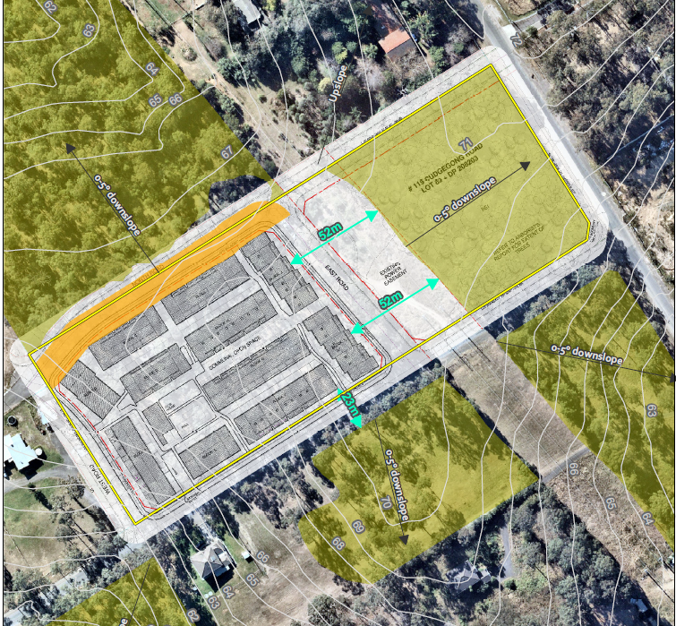

**Figure 3: Bushfire hazard analysis and Asset Protection Zone**

* 1. The proposal was referred to the New South Wales Rural Fire Service (NSW RFS) seeking General Terms of Approval in accordance with Section 91 of the Environmental Planning and Assessment Act 1979, which states that approval is required under Section 100B of the Rural Fires Act 1997.
  2. NSW RFS requested the Applicant demonstrate that the proposal has the adjoining owner’s consent and support before further determination could be undertaken and requested advice as to how the north road (Road No. 2) is to be accessed in the short term given the connecting road crosses over the 2 adjoining lots. It required owner’s consent from both the land to the north and 25 Macquarie Road.
  3. An amended Bush Fire Assessment Report prepared by Peterson Bushfire, dated 6 September 2019, and the owner’s consent from the property to the north were submitted in support of the amended proposal. Owner’s consent was no longer required from 25 Macquarie Road because of the intersection realignment.
  4. NSW RFS has reviewed the submitted amended information. General Terms of Approval have now been re-issued, under Division 4.8 of the *Environmental Planning and Assessment Act 1979*, and a Bush Fire Safety Authority, under section 100B of the *Rural Fires Act 1997*, subject to conditions of consent that include the requirement to apply a restriction to the land use under Section 88B of the Conveyancing Act 1919 over the adjoining property (Lot 83 in DP 208203) for an APZ.

## Telecommunications tower

* 1. The telcommunications tower on the site is leased by Axicom with the lease expiring on 23 July 2022. A referral was sent to Axicom who advised that based on the drawings provided it would appear that there is no excavation to take place that will affect the services to the site. The proposed finished floor levels will need to take into account the exiting pit’s finished level to ensure they are not affected until the site is relocated.
  2. Axicom’s latest ‘as build’ drawings show the lowest antennae are at 28 m tall and this should not be an issue for any plant and equipment being utilised for earthworks.
  3. It was requested that should the design change and the area surrounding the compound be excavated, Axicom will need to review the proposal.
  4. The works associated with the full construction of the road was requested to form the last stage of the development to ensure the road is completed.

## High voltage power lines

* 1. The application was supported by a review of the Electromagnetic Field Report prepared by Magshield Products (Aust) International Pty Ltd, dated August 2019. This report analysed the electromagnetic fields from the existing power lines and their impact on the proposed residential development.
  2. The report concluded and recommended the following:
* The power frequency magnetic field produced by the existing 2 single-circuit 132kV power lines located near the proposed residential development is very small even if the power lines are loaded to the predicted loading conditions well into the future (2042/2043).
* The measures and predicted future magnetic field from the power lines is well within the safe limits of exposure for residents that will be living in the closest units to the power line easement.
* It is not recommended to use the power line easement as a recreational area with a children’s playground.
* There is no consistently evident and scientifically proven association between the exposure to RF electromagnetic field produced by base antennae of mobile telephone network and adverse human health. However, the unnecessary deliberate exposure to such antennae should be avoided. As a general rule for the prevention of high RF exposure, it is recommended to maintain a minimum of 15 m separation distance from such an antenna when a person is elevated to its height while facing it.

## Adaptable housing

* 1. A Statement of Compliance Access for People with a Disability prepared by Accessible Building Solutions was submitted in support of the proposal, where 10% of the dwellings are proposed to be adaptable housing. Nine adaptable dwellings are required to be provided and the designated dwellings are C07, D01, D06, F10, F11, I09, J09, K01 & K08. These dwellings provide living areas including a bedroom on the ground floor with a stairway platform lift being provided from the basement car parking area to the ground and first floor levels where the laundry facilities are provided.